**“The Next Big Revolution: Internet Of Things And Its Applications”**

Dr. Annapurna P. Patil Manoj More S Suresh V

*Associate Professor, BE Student , BE Student,*

*M S Ramaiah Institute Of Technology M S Ramaiah Institute Of Technology M S Ramaiah Institute Of Technology*

*Bengaluru, Karnataka, India Bengaluru, Karnataka, India Bengaluru, Karnataka, India*

[*annapurnap2@yahoo.com*](mailto:annapurnap2@yahoo.com)[*Manoj8894s@gmail.com*](mailto:Manoj8894s@gmail.com)[*er.sureshvelu@gmail.com*](mailto:er.sureshvelu@gmail.com)

***Abstract***

**This Paper presents review of the new era of Computing Technology IoT (Internet of Things). How growth of the Technology, devices connected to the Internet contributes to the M2M & M2H, Wide use of IoT in upcoming days can meet creative worlds needs. RFID being the core term in the IoT , Its Working is clearly explained along with its concerned issues. IoT has the huge contribution to the world and field of computer science. How this technology creates the smart world or Environment is discussed in this paper,and our next volume will give the solution for challenges face in IoT and will run over the experiment which will demo the IoT technology .**

***Keywords***

**IoT** - Internet of Things**, IoE** - Internet of Everything , **M2M** - Machine to Machine Communication ,**M2H**-Machine to Human Communication ,**RFID**-Radio Frequency Identifier , **WSD**-Wireless Sensor Devices , **EPC** - Electronic Product Code, **ONS** - Object Naming Service, **PML** – Physical Markup Language.

**I INTRODUCTION**

We may define “Internet Of Thing has Internet Of Everything that is Existing.” “[1]The Internet of Things (IoT) is generally thought of as connecting things to the Internet. **The Internet of Everything (IoE) is the seamless connection of people, process, data and things. And it’s changing everything.** “

“[1]The IoT creates an intelligent, invisible network fabric that can be sensed, controlled and programmed. IoT-enabled products employ embedded technology that allows them to communicate, directly or indirectly, with each other or the Internet.” IoT can be viewed as a global infrastructure for the information society where it is an integrated part of the future Internet that could be defined as a dynamic global network infrastructure with self-configuring capabilities.

In the 2000s Internet connectivity became the norm for many applications and today is expected as part of many enterprise, industrial and consumer products to provide access to information. However, these devices are still primarily things on the Internet that require more human interaction and monitoring through apps and interfaces. The true promise of the IoT is to make Virtual technology operates behind the scenes dynamically responding to how we want “things” to act.

Kevin Ashton[3] was one of the pioneers, he told that Proctor& Gamble could improve its business by linking RFID information to the Internet. His concept was simple but powerful. If all objects in daily life were equipped with identifiers and wireless connectivity, these objects could be communicate with each other and be managed by computers, here comes the topic of M2M were machine to machine communication which created the environment of objects and devices.

Till today, the world has about 5 billion “smart” connected things to Internet. Survey say there will be 50 billion connected devices by 2020. Those are really big numbers. We need to think how things are fundamentally deployed today is a barrier to realizing those numbers. The industry will only achieve the reality of 50 billion connected devices by simplifying how things connect and communicate today.

Many individual can view the IoT in their own manner , but IoT is finally becoming a hot topic within the mainstream media. Many recent articles point to the IoT as the interaction and exchange of data (lots of it) between machines and creatures, and now there are product definitions reflecting the same concept. Many Companies refer to the Internet of Things in different ways. Few term it has Machine to Machine (M2M) connectivity – essentially the plumbing that connects the devices within the Internet of Things together

Cisco talks about the “Internet of Everything”, while IBM focuses on the ”Smarter Planet”, an interconnected web of systems that enables us to understand the Earth’s central nervous system through the embedded devices around it.

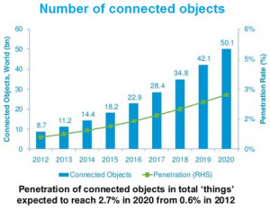

Figure 1: Number of connected objected in 2020

Whatever the language, there’s widespread agreement that the Internet of Things is building rapidly and will form the next wave of computing to affect us all as both businesses and consumers.

**II WHAT IOT CONNECTS?**

• **Connect Everything**[3] **.**

Internet of Things networks began with connecting industrial Machines and equipment with each other were first they concentrated on automating the industrial process, But has the IoT saw the huge grows. At present the vision of IoT has expanded to, Connect everything from industrial equipment to everyday objects and also human beings. IoT has been successful in connecting living organisms such as plants, farm animals and people. For example, the Cow Tracking Project in Essex uses data collected from radio positioning tags to monitor cows for illness and track behavior in the herd. Being successful in creating both M2M and M2H communication.

• **Sensors for data collection** [3]**.**

The physical device are being connected will possess one or more sensors. Sensor has the ability to monitor a specific condition such as location, vibration, motion and temperature which means actually tracking of live world . In IoT, these sensors will connect to each other and to systems that can understand or present information from the sensor’s data feeds this in turn help the object to communicate.

**III. IOTS-DEVICES ABILITY**

* Uniquely identified through the internet backbone
* Ability to communicate through wireless technologies (from RFID and Bluetooth to Wi-Fi and 3G)
* They can report on the world around them through sensors.
* They can be controlled from anywhere through their embedded computers.
* Cloud provides the power to store, exchange, combine and process massive amounts of information.

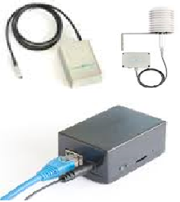

Figure 2: Battery-powered wireless temperature and humidity sensor

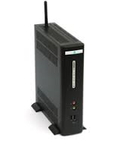

Figure 3: Wireless base station R902 Wireless Ethernet Repeater R824BKe

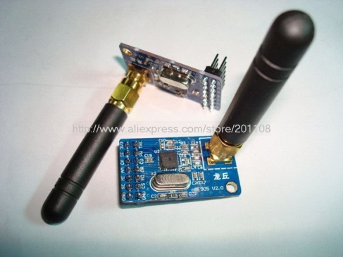

Figure 4: Vehicle monitoring sensor device

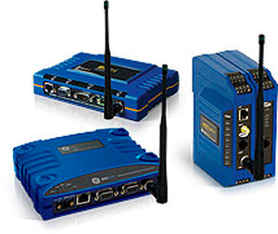

Figure 5: Cordless data acquisition system

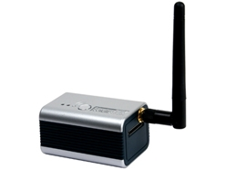

Figure 6: Zigbee wireless temperature sensor

Above shown are the few wireless sensor device in order to make the wireless sensor network we need to use the devices for establish the network ,you can see the use the use of WSN devices in the below architecture were fig 7 shows you us the multi-site wireless monitoring system and fig 8 shows functional overview of a single site.

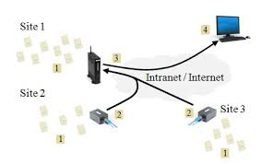

Figure 7: Multi-site wireless monitoring system

Here Base Station monitoring the Multi-site were it involes in the actives of co ordinating the functional of the each site, which inturn is made up of ws devices.

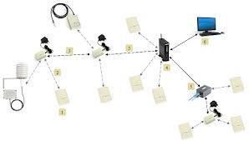

Figure 8: Functional overview

In this functional overview architecture the different devices in a site are inter connected to form a small Wireless sensor network where this devices are in turn are connected to the Base station where there are linked to the Pc which in turn will control and coordinate the functional of the of the WS devices

**IV. WIRELESS DATA ACQUISITION SYSTEM**

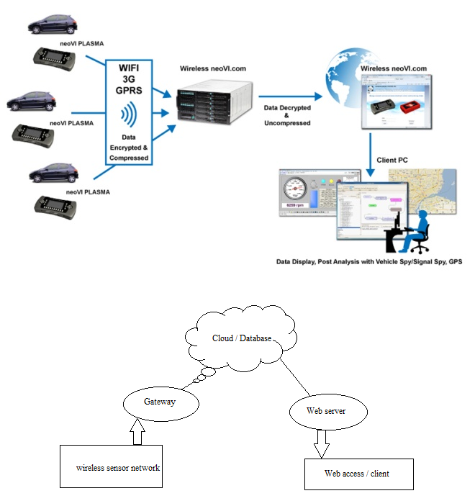

Figure 9: WDAS

When the one or more sensor are connected to the WS devices are enabled in the established network then the WSD will collect the large amount of data from the event taking place and the data collected by this sensors will the loaded on to the cloud (virtual repository, Database) which has the capacity to store huge amount of data, the data are loaded on the cloud by using Wi-Fi, 3G, GPRS, etc.

These data stored on the database are in turn accessed by the client by making use the different application. Cloud provides a convenient user interface to visualize sensor data allows for the devices configuration and user notification in case sensor data exceeds pre-defined threshold.

**V. COMCONCOS’S OF IOT**

**Communication**[3]**.** IoT communicates information to people and systems, such as state and health of equipment. Almost every company has a class of assets it could track. GPS-enabled assets can communicate their current location and movement. Location is important for items that move, such as trucks, but it’s also applicable for locating items and people within an organization. In the healthcare industry, IoT can help a hospital track the location of everything from wheelchairs to cardiac defibrillators to surgeons. In the transportation industry, a business can deliver real-time tracking and condition of parcels and pallets.

**Control and Automation**[3]**.** In a connected world, a business will have visibility into a device’s condition. In many cases, a business or consumer will also be able to remotely control a device. A consumer can use IoT to unlock their car or start the washing machine. Once a performance baseline has been established, a process can send alerts for anomalies and possibly deliver an automated response.

**Cost Convenient**[3]**.** Many companies will adopt IoT to save money. Measurement provides actual performance data and equipment health, instead of just estimates. We have seen companies lose money due to equipment failure. With new sensor information, IoT can help a company save money by minimizing equipment failure and allowing the business to perform planned maintenance. Sensors can also measuring items, vehicle condition agricultural area & high energy consumption devices

**VI. WHAT IS IOT BASED ON AND ITS WORKING**

Internet of things based on RFID which is composed of three major components including RFID system, middleware system and Internet system. RFID system is composed of tags and readers. RFID tags are inexpensive wireless devices which can communicate with RFID readers through antennas.

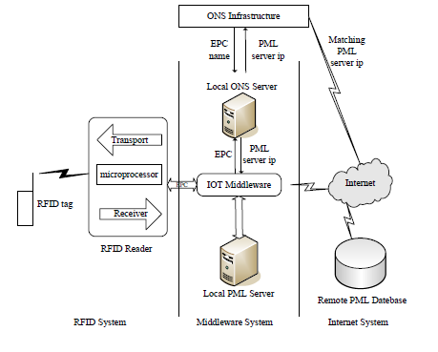

Figure 10: Woking process of IOT based on RFID[9]

The sole EPC (Electronic Product Code) saved in each RFID tag is used to identify a target. The RFID reader is composed of transport, receiver and microprocessor, which is responsible for reading or writing tag information. The antennas play a role in transmitting radio-frequency signal between the RFID tag and the reader.

The middleware system is called Savant system including Savant server, physical markup language (PML) server, Object naming service (ONS) server. Internet system usually consists of computer system and network server including PML database. Has known internet of things based on RFID, RFID reader is responsible for collecting data from RFID tag with sole EPC code. Through this EPC code the middleware system can find corresponding IP address from the ONS infrastructure on the internet, thereby the relevant information of the object can be obtained from this address. Then the middleware system (Savant system) can process and manage the information. In this process there are local ONS server, local PML server and remote PML server which are in charge of data storage.

**Concerned issues**[9]

Based on working process of IOT with respect to RFID.

1. **Leakage**

There may be a chance of leakage of sensitive data of the owner to the unauthorized third party, so the encryption is to be needed to ensure integrity and confidentiality; The RFID reader should confirm before the information is transported, whether it is from correct tag, RFID system should be able to resist denial of service attack (DOS) and protect users’ privacy.

1. **Middleware Security**[9]

Here the main security goal is to protect the communication system between the RFID reader and the database server. Mean while even the database server should be protected to prevent DOS attack. Which is a traditional security issue.

1. **Internet Security**[9]

In the internet system, the traditional network security problems are needed to be solved, for example, how to protect the database from being destroyed and how to guarantee the confidentiality and integrality of data in internet.

**VII. APPLICATION OF IOT**

* Smarts City
* [Environmental Monitoring](http://en.wikipedia.org/wiki/Internet_of_Things#Environmental_Monitoring)
* Object tracking
* Physical safety and perimeter
* [Infrastructure Management](http://en.wikipedia.org/wiki/Internet_of_Things#Infrastructure_Management)
* Smart agriculture
* [Industrial Applications](http://en.wikipedia.org/wiki/Internet_of_Things#Industrial_Applications)
* [Energy Management](http://en.wikipedia.org/wiki/Internet_of_Things#Energy_Management)
* [Medical and Healthcare Systems](http://en.wikipedia.org/wiki/Internet_of_Things#Medical_and_Healthcare_Systems)
* [Building and Home Automation](http://en.wikipedia.org/wiki/Internet_of_Things#Building_and_Home_Automation)
* [Transport Systems](http://en.wikipedia.org/wiki/Internet_of_Things#Transport_Systems)

**VIII. ADVANTAGES OF IOT**

**Quick and smart Connectivity** : We have been using GPS to track movement of delivery trucks. IOT eases and simplifies the entire process by introducing a monitory sensor that helps to track distance and time locations and other contributing factors. It is also useful in the emergency situations like accident, traffic jam, etc.

**World of scan able information:** Rather than the holding a mobile device for information, act of searching something on the Internet will be as simple as looking at it. Products such as Google Glass enables the user with this facilities, users will be able to process scan tags on anything and also contributes to the paper free society .

**Inventory Management (By RFID)**: Inventory management and tracking is also a major task. IOT is used to tag radio frequency sensors to track the location of products in real time. It has been instrumental in tracking the level of inventory and to stock it in advance, making alerts for unforeseen stoppages, automatically placing orders.

**Wearable Computing:** Technology has made the devices that keep track of the human nature to including his health condition, ie wearable which contains the capability of data transfer, emergency alert ,data service etc. this devices server for the growth of medical field.

**Assessing web user intelligence**: IOT is used by third party web data aggregators to have a better understanding of their customer by tracking them on social media networks. This is essential to identify the key customers and their preferences.

**Vending technology**: IOT has played a big role in enhancing the working of vending machines by enabling them to communicate to monitor inventory levels, determine pricing.

**IX. CHALLENGES OF IOT**

**Privacy and Security**[6]**:** Privacy in IoT has prime concern, because each and every data, small information will be sent to the cloud. There may be third parties eye on it, having more information accessible on the web to government agencies, data aggregators, and hackers may not be a comforting thought for members of the public.

**Organizational inability:** IoT being tremendous advanced technology, it will demand a whole new level of systems and capabilities that can handle the huge challenges of ecosystem and unlock value for organizations ,just For instance assume that, we have deployed large amount of Sensors, which collect large amount of data every movement ,there may be a chance of flood of data generated by sensors, hence may require strong data manage­ment, storage and analytics capabilities. Simi­larly, policy makers will need to address.

[**widespread malware**](http://www.anthonyricigliano.info/software-security/): The interconnection of devices could make it much easier for malware to spread . In this type of situation, rather than having one device to fix, there could be numerous devices requiring a sweep of the infecting malware.

**Addressing problem**[6]: we know that around 50 billion devices will be connected to internet by 2020 ,as the number of devices increases in the network they has to be identified by unique number, hence there comes the shortage of address ,and even the survey say that IPV4 address were exhausted on 2011. Address conversion from IPV4 to IPV6 Has IPV4 address are exhausted now devices need to use the IPV6 address so address conversion is also a major issue.

**Energy Consumption:** Has the number of devices increases the energy requirement also increases. Availability of energy resource is major problem in the world.

**X.CONCLUSION**

IOT being hot topic in the field of Computer Technology which aims towards the Smart world, the topics that are discussed here is not only for the purpose of theoretical understanding. We have come across the various types of devices that strengthen the IOT .We have even discussed about the challenges faced in IOT. The aim of the paper was to improve the understating of the reader about the core knowledge of IOT and its application and we have also come across the solutions for the problem faced in IOT such has energy crises and Security management in our upcoming paper Volume II about the Architecture and implementation of IOT setup. This technology is just about just making things smarter and smarter has possible and create the smart data warehouse.

**XI. REFERENCES**

1. Jim Chase,” *The Evolution of the Internet of Things”, Texas Instruments-*September 2013.
2. “*What Internet of Things Needs to Become a Reality”, freescale & ARM-*May 2014
3. *“An Introduction to the Internet of Things (IoT)” Copyright Lopez Research LLC-*November 2013*.*
4. Jun Li, Y. Shvartzshnaider, J. Francisco, R.Martin, K. Nagaraja and D. Raychaudhuri, *“Delivering Internet-of-Things (IoT) Services*

*Mobility First Future Internet Architecture”,* Rutgers University October 24-26th, 2012.

1. [Roberto I. Belda](http://guardianlv.com/author/rbelda/),” *Internet of Things: Advantages May Far Outweigh Its Drawbacks "* January 26, 2014.
2. Dave Evans*,” The Internet of Things How the Next Evolution of the Internet Is Changing Everything”,* Cisco April 2011.
3. Paul Smith,” *What is the Internet of Things – and what does it mean to us all?”,* Agar Scientific, January 2014
4. Chonggang Wang & Mahmoud Daneshmand, *“Special Issue on Internet of Things (IoT): Architecture, Protocols and Services”,* IEEE sensors journal, VOL. 13, no. 10, October 2013.
5. Xiao Nie & Xiong Zhong ,”*Security In the Internet of Things Based on RFID: Issues and Current Countermeasures”,* Published by Atlantis Press, Paris, France 2013.

[10] Kevin Ashton, "That 'Internet of Things'

Thing", [*RFID Journal*](http://en.wikipedia.org/wiki/RFID_Journal), July 22, 2009.